HAVE FAITH IN GOD

Mark 11:12-25
Key verse 22
““Have faith in God,” Jesus answered.”

Introduction
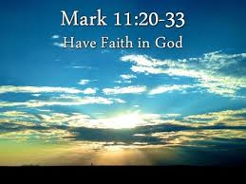
As we begin a new year 2018, we would like to study two passages. In today’s passage Jesus says, “Have faith in God.” When he re-enters Jerusalem on the second day of the Passion Week. Jesus curses the fig tree for not bearing fruit. Among all miracles Jesus performed, this is the only "destructive" miracle. So there must be a great and important lesson in it. God doesn't approve when there is only talk without walk. Jesus wants to challenge his disciples to have absolute faith in God. Having faith in God is not a wishful thinking but an absolute trust in the Lord. May the Lord help us to increase our absolute faith in Him. Also Jesus teaches about mountain moving faith in prayer, especially forgiving others. The point is that this is an area where we need great faith. Sometimes an unforgiving heart is bigger than any mountain. May the Lord help us to increase our faith of forgiving especially among our fellow believers.

1. Read verses 12-18. Why did Jesus curse the tree? (12-14) How did Jesus clear the temple courts? (15-16) What did Jesus teach about the purpose of His house? (17) How did the religious leaders reply to Jesus? (18)

1-1, Read verses 12-18.

The next day as they were leaving Bethany, Jesus was hungry. 13 Seeing in the distance a fig tree in leaf, he went to find out if it had any fruit. When he reached it, he found nothing but leaves, because it was not the season for figs. 14 Then he said to the tree, “May no one ever eat fruit from you again.” And his disciples heard him say it. 15 On reaching Jerusalem, Jesus entered the temple courts and began driving out those who were buying and selling there. He overturned the tables of the money changers and the benches of those selling doves, 16 and would not allow anyone to carry merchandise through the temple courts. 17 And as he taught them, he said, “Is it not written: ‘My house will be called a house of prayer for all nations’? But you have made it ‘a den of robbers.’” 18 The chief priests and the teachers of the law heard this and began looking for a way to kill him, for they feared him, because the whole crowd was amazed at his teaching.

1-2, Why did Jesus curse the tree? (12-14)
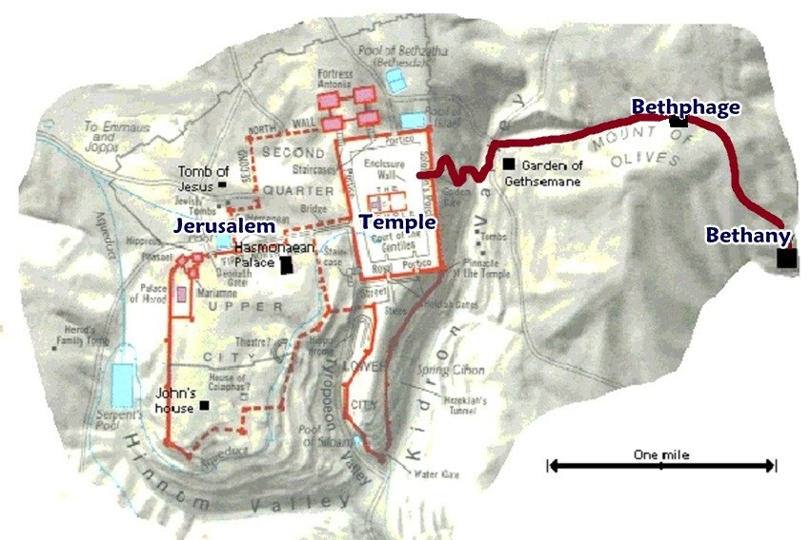
The next day as they were leaving Bethany, Jesus was hungry. 13 Seeing in the distance a fig tree in leaf, he went to find out if it had any fruit. When he reached it, he found nothing but leaves, because it was not the season for figs.

- Throughout the Passion Week, Jesus’ routine was to spend the night in Bethany, a satellite town of Jerusalem, and the home of his beloved friends, Mary, Martha and Lazarus (John 11:1), then to enter Jerusalem for the day.


- Jesus was walking with his disciples from Bethany when he saw a fig tree in the distance. Jesus was hungry that morning. Figs are very nice fruits to eat in the morning as breakfast.

- Jesus was looking forward to having a nice breakfast with figs. Yet when he looked here and there on the tree, he found nothing.

- There were leaves. But there was no fruit. Jesus was very disappointed. Why? The disciples knew that it was not the ripen season for figs. The time was about early Spring according to the flow of the passage.
- In NLT translation, “He noticed a fig tree in full leaf a little way off, so he went over to see if he could find any figs. But there were only leaves because it was too early in the season for fruit.”
- The truth is that a fig tree will always have both leaves and fruit at this time of the year. Jesus was absolutely correct in walking over to the tree expecting to find fruit. Sure, the fruit would not be ripe, but the early fruit should be there if there are leaves.

14 Then he said to the tree, “May no one ever eat fruit from you again.” And his disciples heard him say it.

- Jesus cursed the fruitless fig tree, so that no one might ever eat fruit from it again. The disciples heard him say it.
- It was an unexpected thing from Jesus, for Jesus was usually patient, though his disciples were dull. Jesus is the gentle Savior King to enter the Jerusalem in the previous passage.
- Yet he cursed the fig tree in the presence of his disciples for failing to produce any fruit, though it was not the full season for figs. Obviously, Jesus acted this way precisely so that his disciples would remember this event.
- Perhaps the most obvious answer is that Jesus wanted to reveal the power of faith to his disciples. Jesus challenged them to have faith in God who enables them to do even more than that. Season is not important, what counts is faith!
- This event brings the spiritual struggle to acknowledge God’s Lordship of the world he has made. It is our faith that this world was made by God, and that this world serves to glorify God and to fulfill God’s purpose in making it.
- God has every right to judge this world and mankind, whom he created. Nevertheless, we have a common sense view that God’s judgment of the world should match our idea of objectiveness, fairness and justice.
- We easily find ourselves in the position of judging God. Through his curse of the fig tree, Jesus reminds us of God’s authority as the Judge of all.
- God has the right as God at any moment in our lives to say, “Give me an accounting for your life” (Lk 12:20), even as Jesus demanded that the fig tree be ready to supply him fruit.
- It is our faith that God, who created us, also loves us to help us live up to his purpose. But we must not confuse this faith in God’s mercy and grace with the idea that God is obligated to show us mercy.
- God is merciful to those who don’t deserve it. But God is also the Judge. And as the Judge he has the power and the authority to bring anyone or anything of his Creation before his judgment seat and demand an accounting.
- At the time of giving an accounting, there are no excuses. At the time of God’s judgment, there must simply be fruit corresponding to God’s purpose of creation.

1-3, How did Jesus clear the temple courts? (15-16)

On reaching Jerusalem, Jesus entered the temple courts and began driving out those who were buying and selling there. He overturned the tables of the money changers and the benches of those selling doves, 16 and would not allow anyone to carry merchandise through the temple courts.

- After cursing the fig tree, Jesus and his disciples reached Jerusalem and went to the temple area. Verse 11 says, “Jesus entered Jerusalem and went into the temple courts. He looked around at everything..”
- There Jesus began driving out those who were buying and selling. Apparently, Jesus had been struggling over what he had seen the previous day when he first entered Jerusalem and looked around at everything in the temple. We can imagine that it was the scene at the temple lingering on his mind when he cursed the leafy fig tree that had no fruits.
- There were merchants and money changers all around the temple area in order to provide services for the many tourists and visitors coming to Jerusalem during the Passover Feast.
- The money changers enabled people from every corner of the known world to do business in Jerusalem. The merchants, selling animals for sacrifices and other sacred items, enabled the religious pilgrims to make offerings at the temple, as was their duty according to the Bible.
- But Jesus was not pleased by these activities. Like the leaves on the fig tree, these activities indicated plenty of life and strength in the Jewish community. The merchants and religious leaders had several excuses for why these activities were necessary.
- And yet, Jesus had come as the Judge, and he was now demanding an accounting from his people regarding their use of the temple.

1-4, What did Jesus teach about the purpose of His house? (17)

And as he taught them, he said, “Is it not written: ‘My house will be called a house of prayer for all nations’? But you have made it ‘a den of robbers.’”

- After driving out money changers in the temple courts, he taught the crowd. Jesus declared that the temple of God should be a house of prayer for all nations.
- They should have known that God had not given them the temple for business. God had given the temple as his prayer to make his people a kingdom of priests and a holy nation.
- The Lord’s purpose in giving the temple to Israel was that they might be stewards of the temple so that all nations might eventually come to God in prayer, seeking his presence, living under his mercy. It is the world salvation purpose of God.
- But the temple courts, where foreigners were allowed to go in Jesus’ day, were overcrowded with the merchants and moneychangers.
- So here Jesus set the standard for the correct use of the temple. The temple should be a house of prayer for all nations.
- We have also become temples for the Holy Spirit thanks to Jesus’ blood sacrifice on the cross. We need to know God’s standard for the right use of God’s temple.
1 Co 6:17-19 reads,
“Do you not know that your bodies are temples of the Holy Spirit, who is in you, whom you have received from God? You are not your own; 20 you were bought at a price.Therefore honor God with your bodies.”
- The temple was God’s house. It was provided to the people of God to help them come into his presence, grow as his people and eventually fulfill God’s purpose for them in prayer
- We can present our requests in Jesus’ name, and we can receive God’s wisdom and direction from him and by his Spirit, dwelling in us.
- Jesus said that the Jews had made the temple a den of robbers. He was rebuking the people of God who lived in disobedience to God’s commands, refusing to serve him as his treasured possession, a kingdom of priests and a holy nation.
- Then they came in to the temple and made their sacrifices in order to feel better, with the expectation that God had to forgive them.

1-5, How did the religious leaders reply to Jesus? (18)

The chief priests and the teachers of the law heard this and began looking for a way to kill him, for they feared him, because the whole crowd was amazed at his teaching.
- The chief priests and teachers of the law heard Jesus, and they understood why Jesus was rebuking them. But they did not repent. Rather they decided to kill Jesus.
- People who have hardened hearts against Jesus have no other option than rejecting his words and trying to remove his presence.

2. Read verses 19-23. What did Peter notice and remember (19-21)? How did Jesus answer Peter’s words in v21? (22) What did “Have faith in God” mean to His disciples? What will happen when we have faith in God (23)?

2-1, Read verses 19-23.

19 When evening came, Jesus and his disciples[e] went out of the city. 20 In the morning, as they went along, they saw the fig tree withered from the roots. 21 Peter remembered and said to Jesus, “Rabbi, look! The fig tree you cursed has withered!” 22 “Have faith in God,” Jesus answered. 23 “Truly[f] I tell you, if anyone says to this mountain, ‘Go, throw yourself into the sea,’ and does not doubt in their heart but believes that what they say will happen, it will be done for them.

2-2, What did Peter notice and remember (19-21)?

When evening came, Jesus and his disciples went out of the city. 20 In the morning, as they went along, they saw the fig tree withered from the roots. 21 Peter remembered and said to Jesus, “Rabbi, look! The fig tree you cursed has withered!”

- As they took the same path from Bethany to Jerusalem in the morning, the disciples were walking and probably were anticipating what would happen that day as Jesus taught at the temple.
- They came to the place where Jesus had cursed the leafy but fruitless fig tree, saying, “May no one ever eat fruit from you again!” It was withered from the roots. Peter remembered the scene from the day before and excitedly brought it to Jesus’ attention, saying “Rabbi, look! The fig tree you cursed has withered!”
- The disciples were really impressed by Jesus’ awesome display of power as the Son of God.

2-3, How did Jesus answer Peter’s words in v21? (22)

“Have faith in God,” Jesus answered.
- Jesus rebuked the disciples for their unbelief. But the confession of faith Jesus is looking for is not words or respect. The confession of faith Jesus wants is ‘the practice of having faith in God.’
2-4, What did “Have faith in God” mean to His disciples?
- Although Peter had declared, “You are the Christ,” the disciples had a habit of unbelief. After Jesus had fed the crowds of 5000 people, the disciples worried because they had not brought bread with them into their boat.
- When Jesus told them about his upcoming suffering as the Lamb of God, his disciples would not believe what he told them. Rather, they wondered who would be the greatest. They were filled with practical unbelief regarding the power and will of God.
- So Jesus had to rebuke them, “Have faith in God!” Disciples of Jesus need more than an oral confession of faith. Disciples of Jesus need to practice having faith in God’s power moment by moment in their lives.
- It is not enough to believe a sign that Jesus can make a fig tree wither from the roots. We need to grow in faith in God in trusting His power in each and every aspect of our lives until we can do greater things than Jesus.
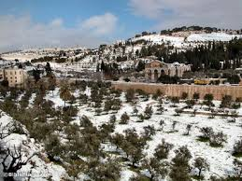
2-5, What will happen when we have faith in God (23)?

“Truly I tell you, if anyone says to this mountain, ‘Go, throw yourself into the sea,’ and does not doubt in their heart but believes that what they say will happen, it will be done for them.

- After Jesus’ rebuke, “Have faith in God,” Jesus gave the disciples God’s promise that any one of them had the authority to cast the Mount of Olives into the sea.
- Jesus’ teaching to his disciples is truly remarkable. Jesus does not want us to admire him for his authority. Jesus wants us to have his authority as the Son of God by having his faith in God.
- Jesus wants his disciples to have the faith to move mountains. No surprise, we call it “Mountain moving faith.”
- Like the disciples, though we believe in Jesus, we have a habit of unbelief. In our unbelief, we see the world around us as full of obstacles. We say, “I have no time, no job, no car, no money and so on” And it sounds true. But it is not. What is our real problem is our lack of faith.
- We may discover often times that in order to come to Bible study or worship service, we should put them into our priority than being with friends, watching sports, having birthday party or making money.
- It’s not easy to make the choice to seek God first, because of our calculation that we might lose our friends, our chance to enjoy ourselves or to make money. Daily it is hard to let go of the opportunities for God, In order to live as a faithful Bible teacher, we need to deny ourselves constantly and consciously to devote for campus outreach ministry.
- We are not created by God to be victims of this world. We are created by God to be rulers and stewards of the world God has made. Anyone can be a ruler and steward when he has faith in God. Anyone can conquer their particular issue by having faith in God.
- America was founded by men and women of faith who had a vision for this nation to be a city on a hill and a source of blessing and inspiration for the world. Don’t tell God how big your problem is, tell your problem how big God is.
- But this nation’s success did not make people give thanks and praise to God. Instead, as a nation we have become fearful to lose what we have received, and afraid that God is not enough to keep us in our supreme position.
- The young people of this nation have fallen into a habit of unbelief, indulging in all kinds of immoral behavior and drug addition to avoiding challenges. Can we really expect that this mountain of unbelief and immorality and bad habit can be challenged by faith and thrown into the sea of history? Yes, of course!
- Jesus challenges us to ‘have faith in God.’ But as we can see, as the problem gets bigger, the nature of the faith we need is made clearer. Faith in God is not an abstract concept, but a real thing like we had studied the book of James. Real faith leads to action. We see Jesus’ faith in God was absolute.
- Therefore, we need the faith of Jesus. We need to practice the faith of Jesus that God is sovereign over each and every event, even as he is sovereign over the entire world.
- We need the faith of Jesus that God’s will and His words are what’s best for mankind and for us. And we need the faith of Jesus to submit to God’s will for our lives, even as he submitted to God’s will humbly to be the Lamb of God for the sin of the world. May God bless this nation a kingdom of priests and a holy nation!

3. Read verses 24-25. How does Jesus want us to express our faith in our prayers (24)? What hinders our prayers? (25a) What happens when we forgive others? (25b)

3-1, Read verses 24-25.

Therefore I tell you, whatever you ask for in prayer, believe that you have received it, and it will be yours. 25 And when you stand praying, if you hold anything against anyone, forgive them, so that your Father in heaven may forgive you your sins.”

3-2, How does Jesus want us to express our faith in our prayers (24)?

24 Therefore I tell you, whatever you ask for in prayer, believe that you have received it, and it will be yours.

- In this verse, Jesus gives us practical advice on how to have his faith in God. First, Jesus’ faith is faith in God’s goodness and power. Jesus said, “Believe that you have received it.” Our greatest struggle while living as Christians in this world is to overcome our fear that God does not want to bless us or help us.
- But Jesus’ faith was that God would do what he asked. Jesus had the right to ask God to save him from trouble. Jesus trusted God’s will for his life, even if it meant that he should face trouble, hardship and even death.
- Jesus was confident that God would answer his prayers on behalf of the sick and needy. We must have faith in God that God’s will for our lives is best. We must have the faith of Jesus that God wants to help us carry out His will, even in the face of the darkness and evil of the world.

3-3, What hinders our prayers? (25a)
3-4, What happens when we forgive others? (25b)

25 And when you stand praying, if you hold anything against anyone, forgive them, so that your Father in heaven may forgive you your sins.”

- Why should we forgive the person who hurts us? It is because God first forgives our sins. Here Jesus teaches us that faith in God is faith in God’s grace.
- In a sense, faith in God that moves his heart is faith in his mercy to forgive sinners. Faith in God’s mercy is faith to practice his mercy toward others by forgiving them.
- We must forgive our enemies and even our friends if they betrayed us. Forgiveness is not just simply forgetting, but changing the way we relate to that person entirely based on God’s grace and forgiveness received in our lives.
- God’s grace and mercy flow through us to others if we truly rely on His. May God bless us with faith in God’s goodness and mercy and love! In this way, may God help us to practice the faith of Jesus that moves the mountains of unbelief.

Conclusion
When we have Jesus’ faith in God, we can challenge every situation and problem with a sense of God’s victory. Most of all, with Jesus’ faith in God, we can truly be instruments of God’s righteousness in our generation. May God bless North America to be raised as a kingdom of priests and a holy nation. May God help us to continue to serve Him and His mission continually in 2018!
One word: Have Faith in God!

