GOD HELPS ISRAEL

1 Kings 20-1-43
Key Verse 28
The man of God came up and told the king of Israel, “This is what the Lord says: ‘Because the Arameans think the Lord is a god of the hills and not a god of the valleys, I will deliver this vast army into your hands, and you will know that I am the Lord.’”


Introduction
Oftentimes we tend to limit the power of God according to our own negative thoughts. Today the author mentioned about Ahab and his relationship with the king of Aram. Contrary to our own expectation, God is working in and through Ahab despite his idol worship. God’s thought is bigger than ours. God’s mercy is beyond our imagination and anticipation. May the Lord help us to accept God’s limitless mercy and love, so that we may expand our scope and vision and cowork with the Holy Spirit like two prophets shown in this passage to serve God’s work by faith on this coming fall semester.

1. Read verses 1-21. Describe the conflict between Ben-Hadad king of Aram and Ahab king of Israel. (1-12) How did God show His mercy to Israel by helping them to win the battle despite their idol worship? (13-21)
1-1, Read verses 1-21.
Now Ben-Hadad king of Aram mustered his entire army. Accompanied by thirty-two kings with their horses and chariots, he went up and besieged Samaria and attacked it. 2 He sent messengers into the city to Ahab king of Israel, saying, “This is what Ben-Hadad says:3 ‘Your silver and gold are mine, and the best of your wives and children are mine.’” 4 The king of Israel answered, “Just as you say, my lord the king. I and all I have are yours.” 5 The messengers came again and said, “This is what Ben-Hadad says: ‘I sent to demand your silver and gold, your wives and your children. 6 But about this time tomorrow I am going to send my officials to search your palace and the houses of your officials. They will seize everything you value and carry it away.’” 7 The king of Israel summoned all the elders of the land and said to them, “See how this man is looking for trouble! When he sent for my wives and my children, my silver and my gold, I did not refuse him.” 8 The elders and the people all answered, “Don’t listen to him or agree to his demands.” 9 So he replied to Ben-Hadad’s messengers, “Tell my lord the king, ‘Your servant will do all you demanded the first time, but this demand I cannot meet.’” They left and took the answer back to Ben-Hadad.10 Then Ben-Hadad sent another message to Ahab: “May the gods deal with me, be it ever so severely, if enough dust remains in Samaria to give each of my men a handful.”11 The king of Israel answered, “Tell him: ‘One who puts on his armor should not boast like one who takes it off.’”12 Ben-Hadad heard this message while he and the kings were drinking in their tents, and he ordered his men: “Prepare to attack.” So they prepared to attack the city. 13 Meanwhile a prophet came to Ahab king of Israel and announced, “This is what the Lordsays: ‘Do you see this vast army? I will give it into your hand today, and then you will know that I am the Lord.’” 14 “But who will do this?” asked Ahab. The prophet replied, “This is what the Lord says: ‘The junior officers under the provincial commanders will do it.’” “And who will start the battle?” he asked.The prophet answered, “You will.” 15 So Ahab summoned the 232 junior officers under the provincial commanders. Then he assembled the rest of the Israelites, 7,000 in all. 16 They set out at noon while Ben-Hadad and the 32 kings allied with him were in their tents getting drunk. 17 The junior officers under the provincial commanders went out first.Now Ben-Hadad had dispatched scouts, who reported, “Men are advancing from Samaria.”18 He said, “If they have come out for peace, take them alive; if they have come out for war, take them alive.”19 The junior officers under the provincial commanders marched out of the city with the army behind them 20 and each one struck down his opponent. At that, the Arameans fled, with the Israelites in pursuit. But Ben-Hadad king of Aram escaped on horseback with some of his horsemen. 21 The king of Israel advanced and overpowered the horses and chariots and inflicted heavy losses on the Arameans.

1-2, Describe the conflict between Ben-Hadad king of Aram and Ahab king of Israel. (1-12)

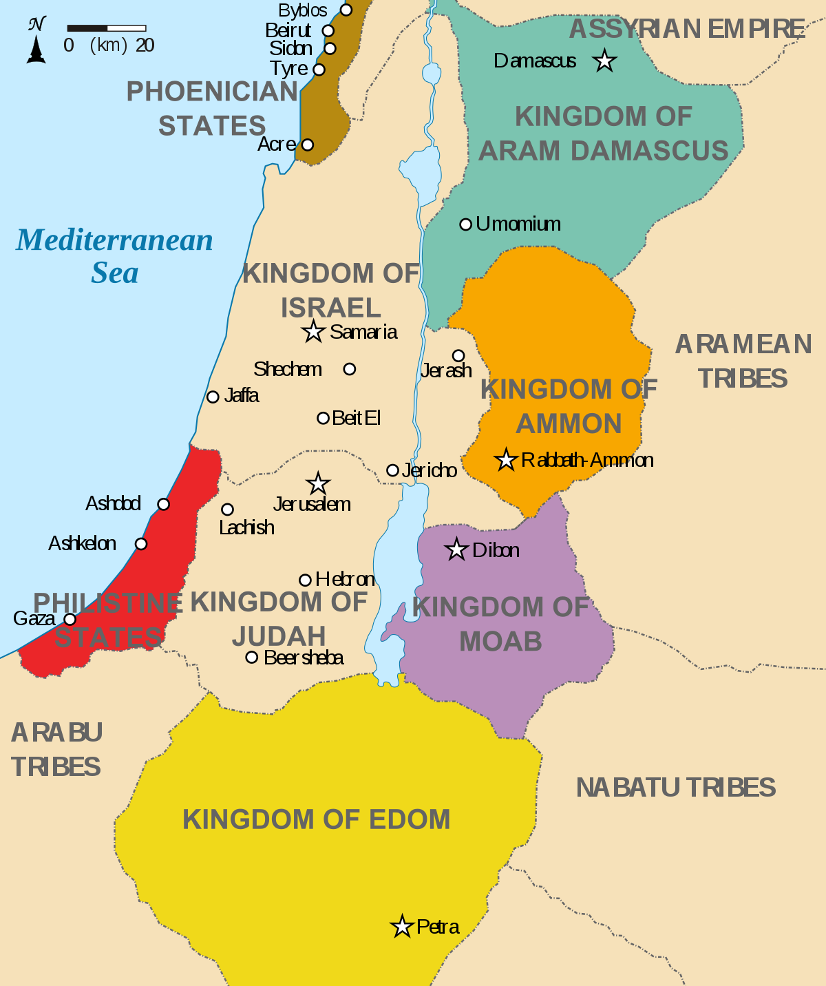
Now Ben-Hadad king of Aram mustered his entire army. Accompanied by thirty-two kings with their horses and chariots, he went up and besieged Samaria and attacked it. 2 He sent messengers into the city to Ahab king of Israel, saying, “This is what Ben-Hadad says:3 ‘Your silver and gold are mine, and the best of your wives and children are mine.’” 4 The king of Israel answered, “Just as you say, my lord the king. I and all I have are yours.” 5 The messengers came again and said, “This is what Ben-Hadad says: ‘I sent to demand your silver and gold, your wives and your children. 6 But about this time tomorrow I am going to send my officials to search your palace and the houses of your officials. They will seize everything you value and carry it away.’” 7 The king of Israel summoned all the elders of the land and said to them, “See how this man is looking for trouble! When he sent for my wives and my children, my silver and my gold, I did not refuse him.” 8 The elders and the people all answered, “Don’t listen to him or agree to his demands.” 9 So he replied to Ben-Hadad’s messengers, “Tell my lord the king, ‘Your servant will do all you demanded the first time, but this demand I cannot meet.’” They left and took the answer back to Ben-Hadad. 10 Then Ben-Hadad sent another message to Ahab: “May the gods deal with me, be it ever so severely, if enough dust remains in Samaria to give each of my men a handful.” 11 The king of Israel answered, “Tell him: ‘One who puts on his armor should not boast like one who takes it off.’”12 Ben-Hadad heard this message while he and the kings were drinking in their tents,[a] and he ordered his men: “Prepare to attack.” So they prepared to attack the city.

- Ben-Hadad, king of Aram together with 32 kings, threatened Ahab twice.
Then Ahab told Ben-Hadad that he was still willing to give in to the first set of demands, but the second set was just too much.
- Ahab said, “Tell him: ‘One who puts on his armor should not boast like one who takes it off.’” This means, “he should not depend on something hoped for until he knows for certain that it will happen.”
- Ben-Hadad was proud of his army. It seemed unstoppable and his victory seemed to be quite sure to his own eyes due to his vast army.
- When Ben-Hadad hears this, he is infuriated. Of course, he is drinking, but now he is drunk and so angry that he prepares to attack at once.

1-3, How did God show His mercy to Israel by helping them to win the battle despite their idol worship? (13-21)
Meanwhile a prophet came to Ahab king of Israel and announced, “This is what the Lord says: ‘Do you see this vast army? I will give it into your hand today, and then you will know that I am the Lord.’” 14 “But who will do this?” asked Ahab. The prophet replied, “This is what the Lord says: ‘The junior officers under the provincial commanders will do it.’” “And who will start the battle?” he asked.The prophet answered, “You will.” 15 So Ahab summoned the 232 junior officers under the provincial commanders. Then he assembled the rest of the Israelites, 7,000 in all. 16 They set out at noon while Ben-Hadad and the 32 kings allied with him were in their tents getting drunk.

- Now, things look very bad for Ahab. Active war was imminent. It seems that it served Ahab right due to all his evil deeds.
- This looks as if God is about to judge Ahab and his family. So far the Lord showed Ahab that the Lord God is the true God, not Baal.
- There was the three-year drought and then the epic battle that proved once and for all that the Lord is God. But Ahab never repented of his sins before God.
- He did not acknowledge that the Lord was God. He did nothing, and now there was a vast enemy army at his door. Maybe the Lord is done with him.
- Maybe Ahab was just too blind and too wicked. He had done so much evil that there is no way back.

- But verse 13 says, “Meanwhile a prophet came to Ahab king of Israel and announced, ‘This is what the Lord says: “Do you see this vast army? I will give it into your hand today, and then you will know that I am the Lord.”’”
- The Lord was going to deliver Ahab from Ben-Hadad and the thirty-two kings. This is so strange and beyond our imagination and contrary to what we would have expected.
- God took an initiative to help him. God reaches out to Ahab and tells him that he will give Ahab victory and then he will know that God is the Lord.
- God chose these junior officers because they have little experience in commanding an army.
- By putting these inexperienced people in charge, there would be no doubt that the Lord is the one who gave victory.
- That is very important, because God is really trying to show Ahab who He really is. God has power over nature and now he was going to show his power.

- So Ahab gathers up the 232 junior officers and puts them in charge, and then he gathers up the rest of Israel to serve as the army, 7,000 in all.
- Compared to the number of people that are called up elsewhere for Israel, the 7,000 men seems a bit small for the entirety of the army.
- It reminds me of 300 soldiers of Gideon. The number is so low, but it serves as a proof that God was going to win the victory, not Ahab.
- So we have a small army with inexperienced leadership heading out to face a vast army of the Devil and many evil spirits in the world, especially on campus!
- But just as God assured Gideon by calling, “the Lord is with you, Mighty Warrior!” Go in the strength you already have.” May the Lord help us to open our eyes to see what we should see in light of God’s mighty power and authority!

17 The junior officers under the provincial commanders went out first. Now Ben-Hadad had dispatched scouts, who reported, “Men are advancing from Samaria.” 18 He said, “If they have come out for peace, take them alive; if they have come out for war, take them alive.” 19 The junior officers under the provincial commanders marched out of the city with the army behind them 20 and each one struck down his opponent. At that, the Arameans fled, with the Israelites in pursuit. But Ben-Hadad king of Aram escaped on horseback with some of his horsemen. 21 The king of Israel advanced and overpowered the horses and chariots and inflicted heavy losses on the Arameans

- When Ben-Hadad’s scouts saw the army coming out of Samaria, they reported it to Ben-Hadad, who told them to take them alive.
- However, Israel did not have such peaceful intentions. They attacked Ben-Hadad’s army and afflicted heavy losses on the Arameans.
- This was definitely a surprise attack to the Aramean king. He fled so that he could regroup. It was a devastating blow to him in the first place.

2. Read verses 22-28. How did the officials of the king of Aram advise Ben-Hadad? (22-25) What did the man of God say to Ahab before the second war? (26-28) How can we overcome our wrong ideas as we fight the spiritual battle?

2-1, Read verses 22-28.
22 Afterward, the prophet came to the king of Israel and said, “Strengthen your position and see what must be done, because next spring the king of Aram will attack you again.”
23 Meanwhile, the officials of the king of Aram advised him, “Their gods are gods of the hills. That is why they were too strong for us. But if we fight them on the plains, surely we will be stronger than they. 24 Do this: Remove all the kings from their commands and replace them with other officers. 25 You must also raise an army like the one you lost—horse for horse and chariot for chariot—so we can fight Israel on the plains. Then surely we will be stronger than they.” He agreed with them and acted accordingly.
26 The next spring Ben-Hadad mustered the Arameans and went up to Aphek to fight against Israel. 27 When the Israelites were also mustered and given provisions, they marched out to meet them. The Israelites camped opposite them like two small flocks of goats, while the Arameans covered the countryside.
28 The man of God came up and told the king of Israel, “This is what the Lord says: ‘Because the Arameans think the Lord is a god of the hills and not a god of the valleys, I will deliver this vast army into your hands, and you will know that I am the Lord.’”

2-2, How did the officials of the king of Aram advise Ben-Hadad? (22-25)
22 Afterward, the prophet came to the king of Israel and said, “Strengthen your position and see what must be done, because next spring the king of Aram will attack you again.” 23 Meanwhile, the officials of the king of Aram advised him, “Their gods are gods of the hills. That is why they were too strong for us. But if we fight them on the plains, surely we will be stronger than they. 24 Do this: Remove all the kings from their commands and replace them with other officers. 25 You must also raise an army like the one you lost—horse for horse and chariot for chariot—so we can fight Israel on the plains. Then surely we will be stronger than they.” He agreed with them and acted accordingly.

- After the victory, the prophet returns to Ahab and tells him to be prepared because the Arameans will return in the next spring. God helped Ahab so that he may not become proud because of the first victory.
- Now, Ben-Hadad’s officials advised him to round up another army, remove the kings from their command and give it to some inexperienced officers, just like Ahab did.
- Then they were to meet Israel for battle on the plains, because according to them, Israel only won because their god is only a god of the hills and has no power on flat land.
- So Ben-Hadad gathers up another army and it is just about the same size as the previous one he had. Another vast army was going to go up and attack Israel.

2-3, What did the man of God say to Ahab before the second war? (26-28)
26 The next spring Ben-Hadad mustered the Arameans and went up to Aphek to fight against Israel. 27 When the Israelites were also mustered and given provisions, they marched out to meet them. The Israelites camped opposite them like two small flocks of goats, while the Arameans covered the countryside.
28 The man of God came up and told the king of Israel, “This is what the Lord says: ‘Because the Arameans think the Lord is a god of the hills and not a god of the valleys, I will deliver this vast army into your hands, and you will know that I am the Lord.’”

- Sure enough, Ben-Hadad gathers up another vast army and meets Israel at Aphek. “The Israelites camped opposite them like two small flocks of goats, while the Arameans covered the countryside.” Again, it looked like an impossible situation.
- At this time, the prophet comes back and tells Ahab, “This is what the Lord says: ‘Because the Arameans think the Lord is a god of the hills and not a god of the valleys, I will deliver this vast army into your hands, and you will know that I am the Lord.’”
- Despite the fact that Israel would be outnumbered a lot, God was going to give victory to Ahab, for God wanted Ahab to know that he Lord is God.

2-4, How can we overcome our wrong ideas as we fight the spiritual battle?

- When we rely on wrong ideas and make excuses based on negative thought and weakness, it will be endless by falling into statistics.
- But this passage shows that we better put our trust in the Lord and rely on the power of God to face the enemies, especially in our one to one spiritual battle.
- May the Lord help us to accept God’s word and hear His gentle voice continually so that we may not be deceived by our wrong ideas.

3. Read verses 29-43. Describe the victory of the Israelites and how Ben-Hadad tried to survive. (29-34) Describe how a prophet condemns Ahab. (35-43) What can we learn from Ahab’s failure to serve God? (39-42)

3-1, Read verses 29-43.

For seven days they camped opposite each other, and on the seventh day the battle was joined. The Israelites inflicted a hundred thousand casualties on the Aramean foot soldiers in one day. 30 The rest of them escaped to the city of Aphek, where the wall collapsed on twenty-seven thousand of them. And Ben-Hadad fled to the city and hid in an inner room.
31 His officials said to him, “Look, we have heard that the kings of Israel are merciful. Let us go to the king of Israel with sackcloth around our waists and ropes around our heads. Perhaps he will spare your life.”
32 Wearing sackcloth around their waists and ropes around their heads, they went to the king of Israel and said, “Your servant Ben-Hadad says: ‘Please let me live.’”
The king answered, “Is he still alive? He is my brother.”
33 The men took this as a good sign and were quick to pick up his word. “Yes, your brother Ben-Hadad!” they said.
“Go and get him,” the king said. When Ben-Hadad came out, Ahab had him come up into his chariot.
34 “I will return the cities my father took from your father,” Ben-Hadad offered. “You may set up your own market areas in Damascus, as my father did in Samaria.”
Ahab said, “On the basis of a treaty I will set you free.” So he made a treaty with him, and let him go.

A Prophet Condemns Ahab
35 By the word of the Lord one of the company of the prophets said to his companion, “Strike me with your weapon,” but he refused.
36 So the prophet said, “Because you have not obeyed the Lord, as soon as you leave me a lion will kill you.” And after the man went away, a lion found him and killed him.
37 The prophet found another man and said, “Strike me, please.” So the man struck him and wounded him. 38 Then the prophet went and stood by the road waiting for the king. He disguised himself with his headband down over his eyes. 39 As the king passed by, the prophet called out to him, “Your servant went into the thick of the battle, and someone came to me with a captive and said, ‘Guard this man. If he is missing, it will be your life for his life, or you must pay a talent[b] of silver.’ 40 While your servant was busy here and there, the man disappeared.”
“That is your sentence,” the king of Israel said. “You have pronounced it yourself.”
41 Then the prophet quickly removed the headband from his eyes, and the king of Israel recognized him as one of the prophets. 42 He said to the king, “This is what the Lord says: ‘You have set free a man I had determined should die.[c] Therefore it is your life for his life,your people for his people.’” 43 Sullen and angry, the king of Israel went to his palace in Samaria.

3-2, Describe the victory of the Israelites and how Ben-Hadad tried to survive. (29-34)
For seven days they camped opposite each other, and on the seventh day the battle was joined. The Israelites inflicted a hundred thousand casualties on the Aramean foot soldiers in one day. 30 The rest of them escaped to the city of Aphek, where the wall collapsed on twenty-seven thousand of them. And Ben-Hadad fled to the city and hid in an inner room.
31 His officials said to him, “Look, we have heard that the kings of Israel are merciful. Let us go to the king of Israel with sackcloth around our waists and ropes around our heads. Perhaps he will spare your life.”
32 Wearing sackcloth around their waists and ropes around their heads, they went to the king of Israel and said, “Your servant Ben-Hadad says: ‘Please let me live.’”
The king answered, “Is he still alive? He is my brother.”
33 The men took this as a good sign and were quick to pick up his word. “Yes, your brother Ben-Hadad!” they said.
“Go and get him,” the king said. When Ben-Hadad came out, Ahab had him come up into his chariot.
34 “I will return the cities my father took from your father,” Ben-Hadad offered. “You may set up your own market areas in Damascus, as my father did in Samaria.”
Ahab said, “On the basis of a treaty I will set you free.” So he made a treaty with him, and let him go.

- This time, the Israelites kill one hundred thousand on the battlefield and a wall crushes another twenty-seven thousand. After a humiliating defeat Ben-Hadad runs into the city and hides in an inner room.
- It is amazing to note how God defeated the Arameans. They were routed by an inferior force. The Israelites had no tactical advantage over the Arameans, but God gave them victory over their enemy.
- Again, we may wonder why the Lord gave these two consecutive great victories to Ahab and Israel? They abandoned him and committed sins against him, but God showed mercy upon them.
- This is the Lord’s infinite mercy. God’s mercy is so vast that it can cover over a multitude of sins. God said to Moses, “I will have mercy on whom I have mercy, and I will have compassion on whom I have compassion.” (Rom 9:14, Exo 33:19)
- God is good and just. Even though God shows mercy on whomever he wants, he still makes sure that justice is still served.
- In this passage, Ahab sees an opportunity with Ben-Hadad’s humiliating defeat. He makes a treaty with him and sets him go.
- It almost looks like Ahab is having mercy on Ben-Hadad, but really, it is for a self-seeking purpose. Well, the Lord wasn’t pleased with him.

3-3, Describe how a prophet condemns Ahab. (35-43)
35 By the word of the Lord one of the company of the prophets said to his companion, “Strike me with your weapon,” but he refused. 36 So the prophet said, “Because you have not obeyed the Lord, as soon as you leave me a lion will kill you.” And after the man went away, a lion found him and killed him. 37 The prophet found another man and said, “Strike me, please.” So the man struck him and wounded him. 38 Then the prophet went and stood by the road waiting for the king. He disguised himself with his headband down over his eyes. 39 As the king passed by, the prophet called out to him, “Your servant went into the thick of the battle, and someone came to me with a captive and said, ‘Guard this man. If he is missing, it will be your life for his life, or you must pay a talent[b] of silver.’ 40 While your servant was busy here and there, the man disappeared.”
“That is your sentence,” the king of Israel said. “You have pronounced it yourself.” 41 Then the prophet quickly removed the headband from his eyes, and the king of Israel recognized him as one of the prophets. 42 He said to the king, “This is what the Lord says: ‘You have set free a man I had determined should die.[c] Therefore it is your life for his life,your people for his people.’” 43 Sullen and angry, the king of Israel went to his palace in Samaria.

- He sent another prophet to him to rebuke him for his actions. The prophet had himself injured and disguised himself as a wounded soldier.
- Then the prophet told this story: “Your servant went into the thick of the battle, and someone came to me with a captive and said, ‘Guard this man. If he is missing, it will be your life for his life, or you must pay a talent of silver.’ While your servant was busy here and there, the man disappeared.”
- When Ahab heard the story, he said that the prophet had announced his own punishment. It would be his life for the life of the prisoner.
- At that, the prophet removed his disguise and revealed himself to the king and turned it back on Ahab, “This is what the Lord says: ‘You have set free a man I had determined should die. Therefore it is your life for his life, your people for his people.’”
- When God said that he was giving the Aramean army into his hands, it meant that the army was to be completely destroyed.
- Ben-Hadad was given to Ahab to destroy or at least hold him captive, but Ahab let him go. He disobeyed God for personal gain and God was not pleased. God’s mercy did not mean that he was unjust as he still rebuked Ahab for his disobedience.
3-4, What can we learn from Ahab’s failure to serve God?

Conclusion
Although this passage’s point appears to be between Ahab and Ben-Hada, the real point is God and His great mercy. The root of this mercy and grace is God’s love. 1 Peter 4:8 says, “love covers over a multitude of sins.” Because God loves us, he is willing to have mercy on us. That is what is going on with Ahab. God’s infinite mercy came to him. God says to all of us, “I love you so much that I want for you to know me, and I will do whatever it takes for you to know me.” God shows his love and mercy to us through Jesus. People often say that they think that they have done too much evil. But God loves them and God loves us. One word: God’s amazing grace!

